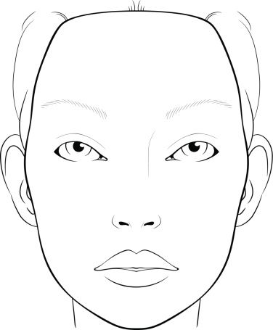
Actor Name:
Character Name:
Show:
Gender:

